Student Name: __________________
Class and Section __________________
Total Points (10 pts) __________________
Due: November 28, 2010 before the class

Project: Investment-Value calculator

CSCI 1302 Advanced Programming Principles
Armstrong State University

Problem Description:
Write a program that calculates the future value of an investment at a given interest rate for a specified number of years. The formula for the calculation is as follows:
futureValue = investmentAmount * (1 + monthlyInterestRate)years*12
Use text fields for interest rate, investment amount, and years. Display the future amount in a text field when the user clicks the Calculate button, as shown in the following figure.

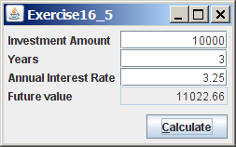

Design:
(Draw a sketch of UI)

Coding:
Name your main class Exercise15_05

Screen shots:

Submit the following items:

1. Submit a hard copy of this document.

2. Compile and Submit to LiveLab as Exercise15_05 (you must submit the program regardless whether it complete or incomplete, correct or incorrect)

3. Fill in self-evaluation:

- Is the UI created correctly? _____
- Is the button action event processed? _____
- Is the calculation performed correctly? _____

